**Operational Reports**

This report will break down students by grade-level whether or not they have a score/data report.

**STEPS:**

From the NWEA Reports dashboard, click operational reports.

In operational reports, click students without valid test results.

Find and click your school, then next.

Select the grade(s) that you want to view (each report must be run separately based on the testing band)

**Grades 1 and 2**—MAP Growth: Math K-2

**Grades 3-5**—MAP Growth: Math 2-5

**Grades 6-8**—MAP Growth: Math 6+

**HS Algebra classes**—MAP Growth: Algebra I

Select mathematics, then create the report.

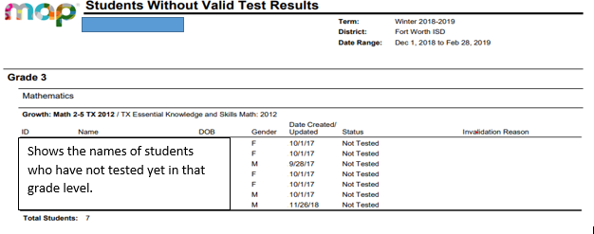Be sure to select the correct test taken for that grade level after choosing the subject; k-2; 2-5; 6+, etc.

Test Events by Status

Shows the names of students who have not tested yet in that grade level.

